SRI AUROBINDO UNIVERSITY
VISION WITH ACTION

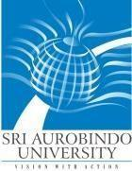

INFORMATION BROCHURE

Post Doctoral Courses
Session: July - 2023
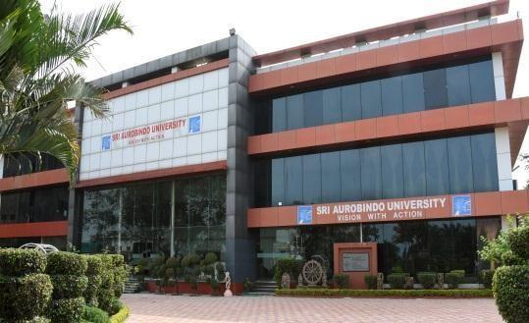

Sri Aurobindo University

Indore-Ujjain State highway, Sanwer Road, Indore-453555 www.sriaurobindouniversity.edu.in
General Rules and Instruction

- Sri Aurobindo University, Indore invites online applications from the prospective applicants for admission in Post Doctoral Courses/ Certificate courses in various medical subjects for Session July – 2023. These courses include Fellowships, Certificate courses, Short term fellowships.
- The admission to Post Doctoral Fellowships/ Post Doctoral Certificate courses shall be governed by Ordinance 16 & 64 and UGC Regulation 2009 and its subsequent amendments.

- The Entrance test and interviews for Post Doctoral Courses/ Certificate courses shall be held offline in University building.

- Applicants are advised to apply only if he/she fulfills the eligibility requirements.

- Applicants must read and understand the information brochure's details before filling out the online application form.

- No written communication regarding Post Doctoral Courses/ Certificate courses shall be provided. Applicants are advised to visit the university website regularly for updates.

- The admission test for Post Doctoral Fellowships/ Post Doctoral Certificate courses comprises of two parts-
  - Entrance Examination.
  - Interview by the selection committee.

All successful candidates in the entrance examination shall have to appear for an interview as per the merit list. The Selection committee will prepare the final eligible list based on marks in Entrance Test and Interview. Candidates shall be admitted to Post Doctoral Fellowships/ Post Doctoral Certificate courses only after approval of the Selection committee.

- The admission test for Short term fellowship/ certificate courses comprises of interview by selection committee only.

- Eligibility: An applicant must hold a recognized postgraduate medical degree recognized by NMC in the concerned specialty as per ordinance. Candidates who have studied in foreign countries (outside India) and qualified Medical PG diploma in clinical courses, FRCS, MRCP, MRCS, FRACS &AB of the concerned specialty are also eligible to apply upon producing Equivalency & Registration certificate issued by NMC and migration certificate issued from the university where post graduate degree was obtained. Migration certificate is required for candidates who have obtained PG degrees from a university outside the state of MP.

How to Apply:

- Interested applicants may apply through the SAU University website: www.sriaurobindouniversity.edu.in

- The fee for application form including entrance fee (Non-refundable) is Rs. 2,000/-
- The name of the applicants must be the same as given in the mark sheet/grade sheet of the 10th Class.

- The information given in the online application form will be verified with the original documents at the time of interview. If is found that an applicant has provided incorrect or false information or withheld some relevant information at the time of filling up the online application form, the applicant shall be debarred from admission or admission can be cancelled at any stage during the course of study without giving prior notice.

- Admit Card: Applicants will be informed about Entrance examination and Interview on their email ID provided prior to the commencement of entrance examination. No separate admit card will be sent.

Date and Time of Entrance Examination

- The Entrance Examination for different disciplines shall be conducted tentatively in 2nd week of January from 11:00 am to 12:00 noon at Sri Aurobindo University, Indore. Exact date of Examination and Interview will be informed to applicant by email 1 week before entrance exam. The duration of entrance examination shall be of 1 hour.

- Applicant is required to report in person for entrance examination on given date at examination center. Non-appearance, for any reason, shall automatically disqualify the candidature for admission.

- Date and Time of Interview: Candidates have to appear for in person interview conducted by selection committee in Sri Aurobindo University on the date of Entrance examination at 2pm. Candidates are instructed to bring their original documents and one set of photo copies for verification before appearing in interview.

- Question paper pattern: The question paper of entrance examination shall consist of 40 MCQs. There will be no negative marking.

- The candidates must score minimum 50% marks in the entrance examination to qualify for the fellowship.

Documents required at time of Verification / Interview

Original certificates and mark sheets along with a self-attested copy of each of the following
  - Mark sheet of 10th, 12th, Graduation, and Post-graduation (MBBS/MD/MS/DNB/DM/MCh)
  - Attempt certificates
  - MBBS and MD/MS Degree certificates
  - Medical Council registration certificate and additional registration certficate.
  - NOC certificate (If bonded candidate)
  - Government issued Identity proof (Preferably Adhar Card)
  - Certificates of Merit/distinction (if applicable)
  - Publications copy along with proof of Indexing of journal (Pubmed/scopus)
  - Certificate of any additional qualifications.
  - Teaching certificates (as Senior resident or Assistant Professor)
  - NOC from previous employer.

- Fellows will be assigned clinical duties by HOD/ Course director to ensure adequate exposure in required field as mentioned in curriculum. It may include emergency duties as well.
- Fellows need to maintain 90% attendance mandatorily and fellows will be entitled for leave as per P.G. rules prescribed by university.
- Candidate seeking admission to Post doctoral fellowship need to publish a Paper in Index Journal during fellowship course. Paper publication is mandatory and it carries 25% of marks in the Internal Assessment.
- At end of fellowship/ Certificate course, candidate need to appear for examination which will consist of clinical examination and viva.

- The decision of the Sri Aurobindo University, Indore regarding any dispute will be final and binding.

- The university reserves the right to modify any information at any stage.

- Any legal dispute is subject to Indore jurisdiction.

- For any query, please contact: 0731- 4788900
or Email: admission@sriaurobindouniversity.edu.in

Important Dates (Tentative dates*):-

Information | Date
Last date of online application | 31/12/2023 till 5:00 pm
Entrance Examination and Interviews | Will be informed after 1st Jan
Course start date | 31st Jan
*Dates are subjected to change, Please visit Website for regular updates.

