SRI AUROBINDO UNIVERSITY
VISION WITH ACTION

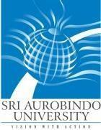

INFORMATION BROCHURE
Post Doctoral Fellowships/ Post Doctoral Certificate courses
Session: July - 2023
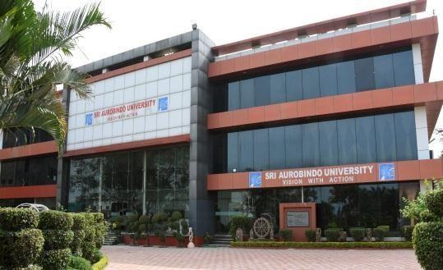

Sri Aurobindo University

Indore-Ujjain State highway, Sanwer Road, Indore-453555 www.sriaurobindouniversity.edu.in
General Rules and Instruction

- Sri Aurobindo University, Indore invites online applications from the prospective applicants for admission in Post Doctoral Fellowships/ Post Doctoral Certificate courses in various medical subjects for Session July – 2023.
- . The admission to Post Doctoral Fellowships/ Post Doctoral Certificate courses shall be governed by Ordinance 16 & 64 and UGC Regulation 2009 and its subsequent amendments.

- The Post Doctoral Fellowships/ Post Doctoral Certificate courses Entrance Test shall be held in University building.

- Applicants are advised to apply only if he/she fulfills the eligibility requirements.

- Applicants must read and understand details given in the information brochure before filling the online application form.

- No written communication regarding Post Doctoral Fellowships/ Post Doctoral Certificate courses shall be provided. Applicants are advised to visit university website regularly for updates.

- Post Doctoral Fellowships/ Post Doctoral Certificate courses comprises of two parts-
  - Entrance Examination.
  - Interview by selection committee.

All successful candidates in entrance examination shall have to appear for interview as per merit list. The final eligible list will be prepared by the Selection committee on the basis of 50% marks in Entrance Test and Interview. Candidates shall be admitted to Post Doctoral Fellowships/ Post Doctoral Certificate courses only after approval of Selection committee.

- Eligibility: An applicant must hold a recognized postgraduate medical degree recognized by NMC in concerned specialty. Candidates who have studied in foreign countries (outside India) and qualified Medical PG diploma in clinical courses, FRCS,MRCP,MRCS, FRACS &AB of concerned specialty are also eligible to apply upon producing Equivalency & Registration certificate issued by NMC and migration certificate issued from university where post graduate degree was obtained.

How to Apply:

- Interested applicants may apply through SAU University web site:
www.sriaurobindouniversity.edu.in

- The application form includes entrance fee (Non-refundable) is Rs. 2,000/- upto 15th June 2023 till 5 pm.
- Applicants can pay fee online through SAU online link

- The name of the applicants must be the same as given in the mark sheet/grade sheet of the 10th Class.

- The information given in the online application form will be verified with the original documents at the time of interview. If is found that an applicant has provided incorrect or false information or withheld some relevant information at the time of filling up the online application form, the applicant shall be debarred from admission or admission can be cancelled at any stage during the course of study without giving prior notice.

- Admit Card: Applicants will be informed about Entrance examination and Interview on their email ID provided prior to the commencement of entrance examination. No separate admit card will be sent.

Date and Time of Entrance Examination

- The Entrance Examination for different disciplines shall be conducted from 22th June – 26th June from 11:00 am to 12:00 noon at Exam Hall, Sri Aurobindo University, Indore. Exact date of Examination and Interview will be informed to applicant by Email 1 week before entrance exam. The duration of entrance examination shall be of 1 hour.

- Applicant is required to report in person for entrance examination on given date at examination center. Non-appearance, for any reason, shall automatically disqualify the candidature for admission.

- Date and Time of Interview: Candidates have appear for interview conducted by selection committee in Sri Aurobindo University on the date of Entrance examination at 2pm. Candidates are instructed to bring their original documents and one set of photo copies for verification before appearing in interview.

- Question paper pattern: The question paper of entrance examination shall consist of 40 MCQs. There will be no negative marking.

- The candidates must score minimum 50% marks in the entrance examination to qualify for the fellowship.

Document required at time of Verification / Interview

- Original certificates and mark sheets along with a self-attested copy of each of the following
  - Mark sheet of 10th, 12th, Graduation, and Post-graduation (MBBS/MD/MS/DNB/DM/MCh)
  - Attempt certificates
  - MBBS and MD/MS Degree certificates
  - Medical Council registration certificate and additional registration certficate.
  - NOC certificate (If bonded candidate)
  - Government issued Identity proof (Preferably Adhar Card)
  - Certificates of Merit/distinction (if applicable)
  - Publications copy along with proof of Indexing of journal (Pubmed/scopus)
  - Certificate of any additional qualifications.
  - Teaching certificates (as Senior resident or Assistant Professor)
  - NOC from previous employer.

- The decision of the Sri Aurobindo University, Indore regarding any dispute will be final and binding.

- The university reserves the right to modify any information at any stage.

- Any legal dispute is subject to Indore jurisdiction.

- For any query, please contact: 0731- 4788900
or Email: admission@sriaurobindouniversity.edu.in

Important Dates:-

Information | Date
Last date of online application | 15/06/2023 till 5:00 pm
Entrance Examination and Interviews | 22nd -26th June 2023
Result Declaration | 30th June 2023
Course start date | 1st week of July
Last date of Course Fee submission | 7th July 2023

Details of various Post Doctoral Fellowship /Post doctoral Certificate courses Session July 2023

