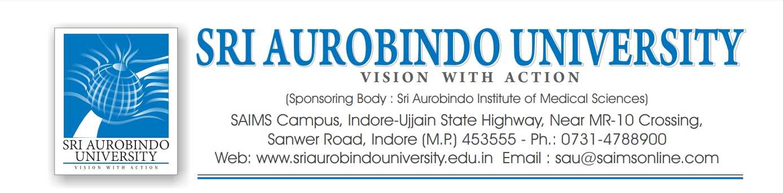
ADMISSION OPEN FOR Ph.D PROGRAMMES
Applications are invited from eligible candidates for various Ph.D Programmes in prescribed format provided on our website. The details are as follows:-

- The Applications are invited in different subjects of Medical, Dental, Nursing, Physiotherapy, Rehabilitation Sciences, Journalism and Mass Communication and Law.

- The Application form will be available from : 1st April 2023

- Last date of submission of application form : 30th April 2023

- The Entrance Test will be conducted on : 15th May 2023

- Selection of eligible candidate shall be through written exam and interview as per UGC/Regulatory body norms.

- The detailed information regarding Application form, fees structure, pattern of Entrance test, rules, statute etc. are available in the information brochure of University website : www.sriaurobindouniversity.edu.in

- Interested candidates should apply through university portal https://sriaurobindouniversity.edu.in/phd-2022 along with scanned copies of their mark sheets, passing certificate and Photo ID Proofs

Contact Details
Sri Aurobindo University
(Sponsoring Body: Sri Aurobindo Institute of Medical Science)
SAIMS Campus, Indore-Ujjain State Highway, Near MR -10 Crossing,
Sanwer Road, Indore (M.P.) 453555 – Ph.:07314788900
Web: www.sriaurobindouniversity.edu.in Email:sau@saimsonline.com

Sd\-
Dr. Anand Misra
Registrar

